Item 4.iii: Locational Based Line Loss Calculations

Joint IOUs’ Revised Proposal
  - LNBA Working Group

Summary of Recommendations
After performing additional line loss studies to enhance understanding of line loss variance across distribution feeders and distribution secondary systems, the joint IOUs have the following proposals for how line loss changes should be accounted for in the various LNBA uses cases.

- For the DERAC calculator/cost effectiveness use cases the IOUs recommend that we continue to use each IOU’s respective publicly available transmission and distribution loss factors as multipliers to the avoided energy cost/peak generation capacity value streams a DER is forecasted to provide. The system average values will adequately reflect the added value of typical DERs in reducing line losses without overcomplicating data input to the calculators or the analysis required to produce the LNBA mapping layers. The previously used distribution factors include both distribution primary and secondary system losses. Variation in secondary system losses will be disregarded due to lack of significance when evaluating DERs cost effectiveness at a high level
- For the project deferral/deferral framework use case the IOUs recommend that some level of locational differentiation of losses will be incorporated into the LNBA tool; the level of detail is contingent on volume of projects identified in each IOU’s system-wide rollout of LNBA for the deferral use case. The more location specific loss factors will be included in the LNBA tool to be recalculated and displayed on the heat maps. As a potential future improvement of the LNBA tool, locational loss factors would also reflect different voltage levels at which DER may be deployed: primary or secondary. Considering the challenges and variation of secondary systems, the first initial implementation will include loss factors from the primary distribution system. Consistent with the analysis presented here, some DERs not coincident with load that may increase losses and will be assessed as providing less generation avoided costs.

Introduction and Background

DERs alter the amount of energy losses on various parts of the electric grid differently, therefore the IOUs have segregated the evaluation of line losses to different portions of electric system. The IOUs have evaluated DER impact on the losses realized on the transmission, sub transmission (blue), distribution primary (green), and distribution secondary systems (red). The diagram below illustrates these separate systems.
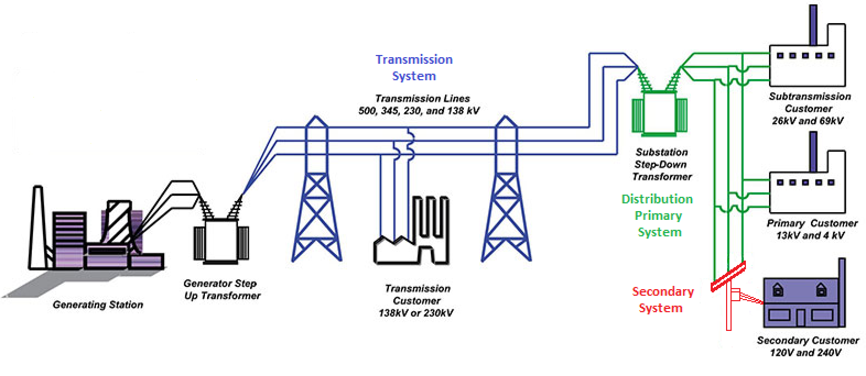

As part of Demonstration Project B (Demo B), the IOUs coordinated with E3 to develop the LNBA calculator tool which includes IOU system wide average loss factors for distribution and transmission. The loss factors were used to estimate the additional avoided energy costs, avoided generation costs, and avoided capacity needs at peak realized by a DER in reducing line losses. To clarify how these loss factors were applied in evaluating DER value see the example below.

EXAMPLE:

IF….
Distribution System Losses (D_{Losses}) =4%
Transmission System Losses (T_{Losses}) =2%
Pre DER Circuit load = 6 MW continuous
DER Rating= 1 MW continuous

THEN
Pre DER yearly circuit energy consumption = 6MW *8760 Hours = 52,560 MWh
Pre DER yearly circuit energy losses = 52,560 MWh*(T_{Losses}+ D_{Losses}) =52,560 MWh * .06 = 3153.6 MWh

Yearly avoided energy credited to DER = DER Rating *(1 + (T_{Losses}+ D_{Losses}))* 8760 hours =
1 MW *1.06 *8760 = 9285.6 MWh -8760MWh = 525 MWh exclusively derived from reduction in yearly line losses

Avoided Generation Capacity (Resource Adequacy) = DER Rating * (1 + (T_{Losses}+ D_{Losses})) = 1MW *(1+(.02+.04) = 1.06MW resultant avoided RA

Increased Distribution Circuit Capacity = DER Rating * (1 + D_{Losses}) = 1MW *(1+.04)= 1.04 MW Line capacity increase (For project deferral)

The LNBA working group expressed concern that using the system average loss values was not a sufficient way to account for the locational variability in DER line loss reduction. While the LNBA working group acknowledged that the variation in losses may not be significant enough to warrant intense IOU effort to develop the tools necessary to estimate line loss reduction more accurately and then extend the LNBA tool to incorporate more granular losses system-wide, the working group decided it was worth examining in greater detail. The IOUs then performed a more detailed evaluation of line loss variation for the greater WG to determine if detailed calculations of line losses were worth pursuing and if so to what degree of accuracy. The results of this preliminary study were presented at the November WG meeting and are included below.

Line Loss Variability Study Results

Per the September LNBA WG meeting each IOU was to perform an analysis using the following steps:

- Select a sample size of distribution feeders to evaluate in preliminary study
- Define circuit types to reflect differing characteristics
  - i.e. Rural large service area, urban small service territory, and suburban medium size territory
  - Uniform loading, spot load, express run circuit
  - High % loaded circuit, medium %. Low %
- Evaluate base circuit model for maximum, minimum, and median loading levels to see the baseline %/kW losses on each circuit
- Model generation on baseline conditions created in #2
- Record the kW losses from baseline condition determined from #2
- Calculate maximum losses % change and min loss %
- Use line loss study results to estimate sensitivity on LNBA results
- Perform similar study for secondary network scaling generation and load

Example Results:
To aid with interpretation of the results, consider the following example:
Power flow results with no new DER added:
- Feeder Native Load (aka end use consumption): 5 MW
- Feeder Line Losses: 250 kW
- New DER Generation: 0 MW
Power flow results with new DER added:
- Feeder Native Load (aka end use consumption): 5 MW
- Feeder Line Losses: 200 kW
- New DER Generation: 1 MW
The effect of adding a 1 MW DER on the line losses was a 50 kW reduction. Hence as a percent of the DER size, the loss factor is 50kW/1000kW = 5%. The results below are presented as percent as in the example above as well as kW. To convert kW to percent simply divide by 1,000. A hypothetical meter at the feeder head would read 5,250 kW before the DER is added and 4,200 kW after the new DER.

Southern California Edison Results

Distribution Primary % Line Loss Reduction Relative to 1 MW Generator Nameplate

San Diego Gas & Electric Results (12kV)

% Line Loss Reduction Relative to 1 MW Generator Nameplate

Individual Circuit kW Line Loss Reduction with 1 MW Generator at Median Load

Individual Circuit kW Line Loss Reduction with 1 MW Generator at Peak Load

Pacific Gas & Electric
Loss Reductions as % of nameplate for 1 MW Generator on Representative Urban/Suburban Substation Circuit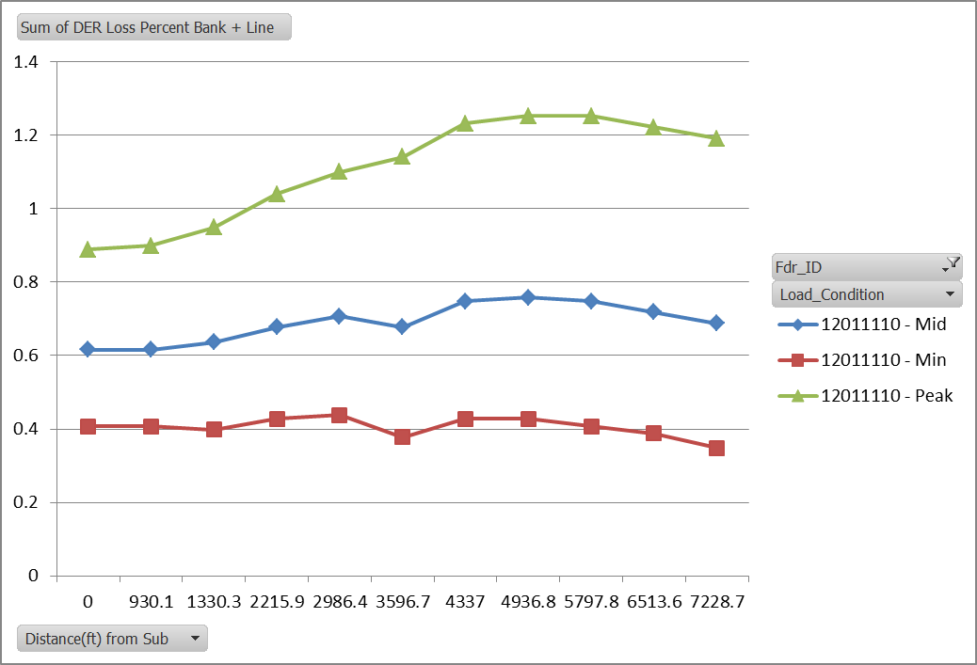
Loss Reductions as % of nameplate for 1 MW Generator on Representative Rural Substation Circuit
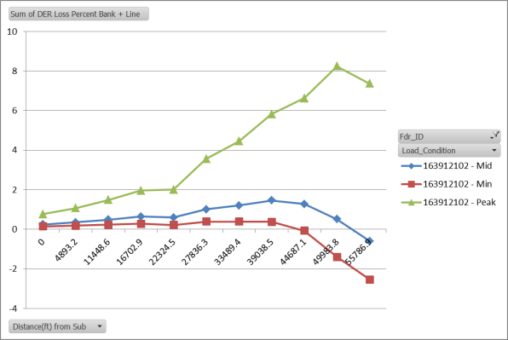
Loss Reductions as % of nameplate for 1 MW Generator on Representative Lightly-Loaded Circuit

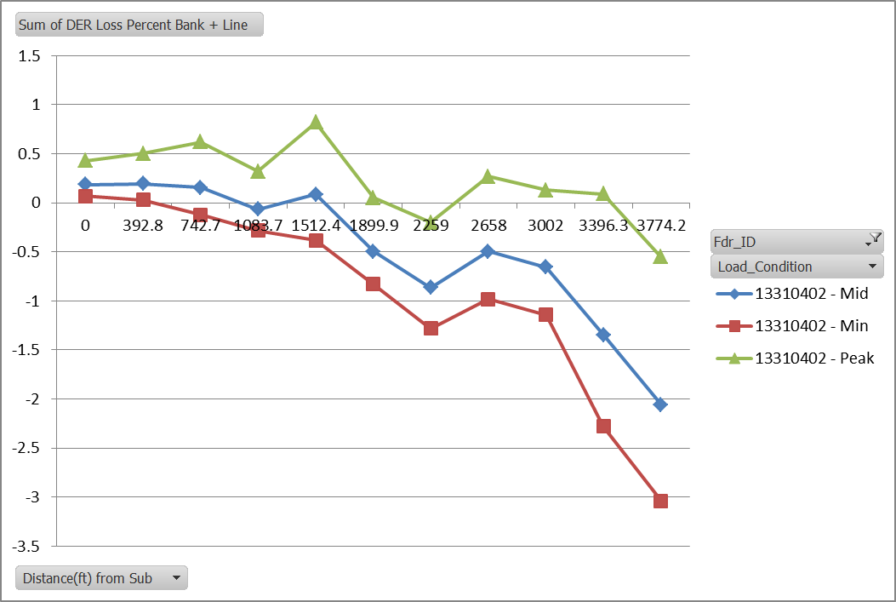

Secondary System Losses Study

Model of Secondary Network with 8 Residences with Generators
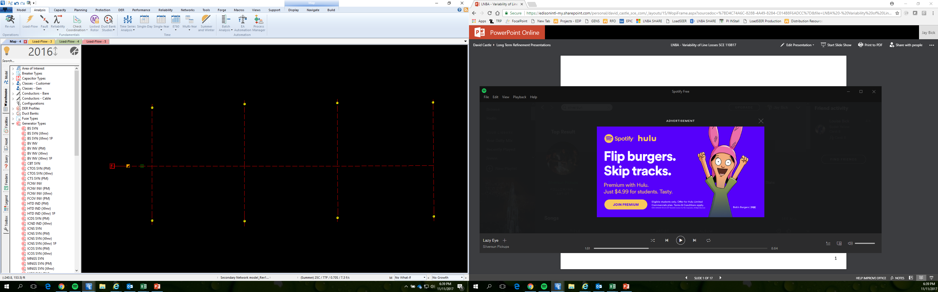
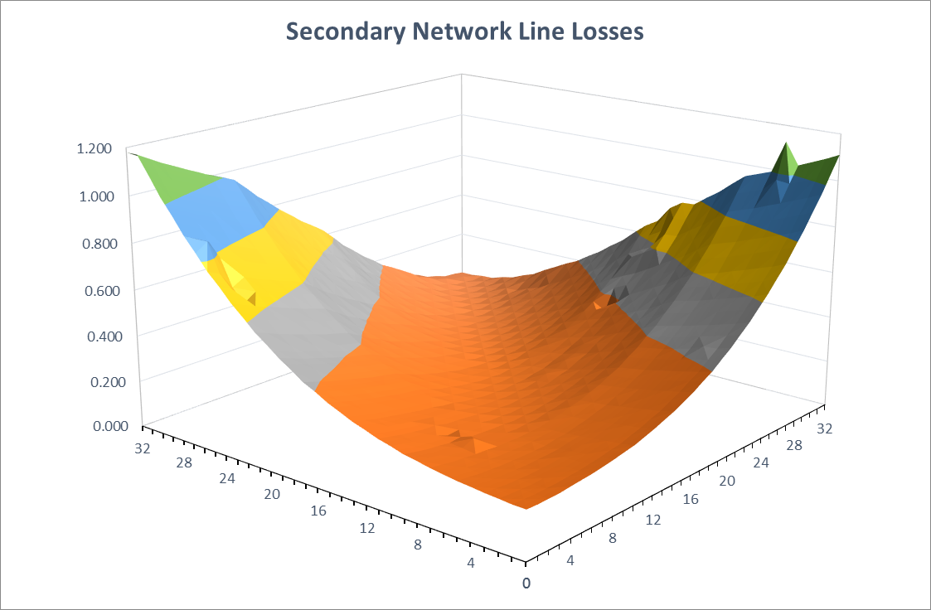
Load
(kW)
Generation
(kW)
Losses
(kW)

Overall study Findings
- For 4 kV distribution lines, the amount of line losses was not significantly reduced when simulating a 1 MW generator at various locations.
- Adding 1 MW generator on 4kV circuit typically resulted in reverse power flow and increased line losses.
- When DER generators cause reverse power flow through the distribution service transformer or the substation transformer, the total distribution line loss benefit decreases, can reach zero, or negatively impact losses if DER generation exceeds the loading on the circuit it’s interconnected.
- Rural feeders tend to be longer and higher impedance, and have more locations with high peak losses as well as overall variance in line losses to feed each line section.
- Back-feeding does cause losses to increase in certain locations on the primary distribution feeder.
- Urban feeders are typically stout, low impedance, short length, and have low losses so they are not highly location sensitive.
Losses on the secondary network are mainly derived from net transformer loading and will be minimal when generation is coincident and sized to match load (i.e. load is fed from generation locally).

Conclusion
- For Cost Effectiveness Use Case in DERAC
  - Maintain Status Quo in publicly available LNBA Calculator tool and DERAC calculators.
  - As DERAC becomes more granular, incorporate additional public loss factors corresponding to additional granularity (e.g. LCR-level transmission loss factors).
- Deferral Framework Use Case
  - Incorporate more locational differentiation of losses within the LNBA tool
  - Variation in losses can be significant for “outlier” locations (e.g. at a location with 25% losses at peak, a 800 kW generator can provide 1 MW load reduction at the transformer)
- Evaluation approach will depend on number of deferral opportunities and associated circuits that pass through deferral screens TBD in track 3
      - If a small number of feeders, more detailed modeling could be feasible
      - If a large number of feeders, a clustering/representative feeder approach may be needed.
- IOUs will incorporate one of the above approaches in the 2018 roll out of LNBA heat map and public tool

The DERAC tool currently uses PTO-level average transmission loss factors; however, once LCR area granularity for generation capacity avoided costs is incorporated into LNBA, then LCR area specific transmission loss factors can be applied.
Note that since the load is flat in all hours, the peak loss factor used to calculate avoided generation capacity is the same as the average loss factor used to calculate avoided energy. More typically, a distinction is made to calculate generation capacity and energy avoided cost, respectively.

