Item 4: Locational Based Line Loss Calculations

Joint IOUs’ Initial Proposal
  - LNBA Working Group

Summary of Recommendations
- The LNBA working group (WG) collectively recommends that the existing system loss factor in the LNBA tool be split into several loss factors separately accounting for losses any DER may alter on a local transmission area, sub transmission, distribution primary, and distribution secondary systems they are interconnected and downstream of. The diagram below illustrates these separate systems.
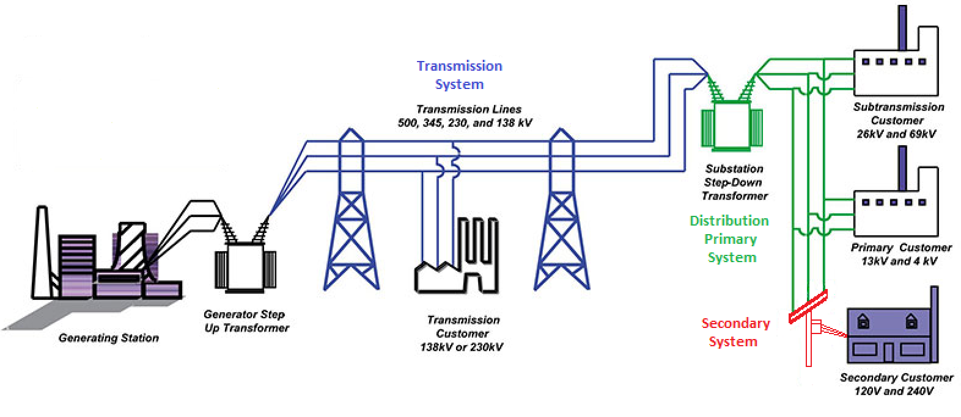

- The LNBA WG recommends that the transmission loss factor remain the same for all DERs in each respective transmission area identified by CAISO as transmission losses will not be significantly impacted by deploying DER in one location vs another within these areas.
- SCE will perform a study on their own behalf to evaluate if their sub-transmission losses vary significantly by location. (SCE specific)
- The IOUS will expend the most effort evaluating distribution primary losses in a more detailed circuit modeling exercise for some subset of each IOUs distribution circuits. The evaluation will help determine the effect of DER location on distribution circuit losses and will help guide how loss factors should be included in the LNBA and whether the IOUs should pursue a more elaborate/labor intensive methodology of calculating location specific loss factors for each circuit/section
- The IOUs will also perform an evaluation of secondary system losses
- Future analysis may evaluate losses incurred by backfeeding secondary networks and distribution transformers.
- IOUs will develop high level cost estimates/timeframes of implementing various line loss calculation methodologies

Introduction and Background
As part of Demonstration Project B (Demo B), the IOUs coordinated with E3 to develop the LNBA tool which includes IOU system wide specific loss factors. The loss factors were used to estimate the benefit that DERs provide by avoiding line losses. For example, if a customer needs 0.9 MWh of energy, a generator would need to provide 1.0 MWh of energy to account for 10% line losses to deliver that energy. Locating DERs near the customer to provide the energy would avoid the both the energy needed by the customer as well as the energy needed to account for the line losses.

As part of the assigned commissioner ruling on long term refinements to ICA and LNBA, the Commission requests to “incorporate additional locational granularity into…line losses.” The working group has suggested, as a first step, assess the variability of the line losses.

Discussion
- For a typical Electric system with large scale transmission interconnected generation feeding customers far away from its generating sources average losses are typically around 10%
- The existing LNBA tools currently calculates a DERs ability to reduce losses by either reducing load or delivering generation closer to load by multiplying the DER output by 1+system average loss factor. (if the average system losses was 10% this number would be 1.1) In addition to this the LNBA tool also evaluates the DER as providing 1.1 * its output for capacity reduction which help smaller DERs meet larger load reduction requirements in the interest of deferring a project
- Calculating losses is computationally intense because losses increase or decrease based on many different variables. Loading, load frequency, load allocation on a circuit, circuit conductor length, voltage level, conductor type, generation location, capacitor location, power factor, system operations, and other factors all play a role in determining losses.
- Because so many components go into line loss calculations one requires a large amount of data as well as data accuracy to accurately calculate line loss reductions caused by a DER. Even with precise data and calculations the distribution systems are dynamic in that loads, generation, and circuits configurations are subject to change all the time so the value of reduced losses is an estimate only.
- The LNBA WG acknowledges there may not be evidence that the variation in loss reduction is significant enough to warrant intense IOU effort to develop the tools necessary to estimate line loss reduction more accurately, however the IOUs will conduct a preliminary evaluation of line loss variation in order for the greater WG to determine if it is actually worth pursuing and if so to what degree of accuracy. The results of this preliminary study will be presented at the November WG meeting.
  - Each IOU will perform an analysis that follows the following steps:
    - Select a set of feeders for analysis seeking to capture a cross section on characteristics most likely to influence losses (e.g. length, voltage, loading)
    - Evaluate variability of losses among the selected feeders
    - Evaluate variability of losses within the selected feeders (i.e. different locations on each feeder)
    - Evaluate LNBA results sensitivity to losses
    - Recommend locational loss factor approach for LNBA tool (e.g. level of granularity, method for developing loss factors) that balances complexity with need to capture loss factor variability as a driver of LNBA results
- The preliminary study will serve to allow the allocation of resources to studying issues that have a more quantifiable impact to the LNBA than line losses in the interim.

Conclusion and Next Steps
- Perform the Preliminary study on distribution primary line losses, secondary losses, and export losses and share results with working group at meeting in November.

Addendum
CAISO Transmission Areas and Peak Period Losses

Peak Load Transmission Losses - CAISO 2012
Area | Busload (MW) | Losses (MW) | Pumps (MW) | Total | Losses | Source:
LA Basin | 19,300 | 133 | 27 | 19,460 | 0.7% | (1)
San Diego/Imperial Valley | 4990 | 134 |  | 5,124 | 2.6% | (1)
Humboldt | 200 | 10 |  | 210 | 4.8% | (2)
North Coast/North Bay Area | 1386 | 34 |  | 1,420 | 2.4% | (2)
Sierra | 1713 | 103 |  | 1,816 | 5.7% | (2)
Stockton | 1067 | 19 |  | 1,086 | 1.7% | (2)
Greater Bay Area | 9493 | 197 | 264 | 9,954 | 2.0% | (2)
Greater Fresno Area | 3014 | 105 |  | 3,119 | 3.4% | (2)
Kern Area | 1099 | 11 |  | 1,110 | 1.0% | (2)
Big Creek/Ventura | 4260 | 78 | 355 | 4,693 | 1.7% | (2)
System Average |  |  |  |  | 1.8%
Renewables Areas |  |  |  |  | 2.7%
(1) - CAISO, 2013 LOCAL CAPACITY TECHNICAL ANALYSIS ADDENDUM TO THE FINAL REPORT AND STUDY RESULTS: Absence of San Onofre Nuclear Generating Station (SONGS), August 20, 2012
(2) - CAISO, 2012 LOCAL CAPACITY TECHNICAL ANALYSIS FINAL REPORT AND STUDY RESULTS, April 29, 2011

See CAISO, 2012 LOCAL CAPACITY TECHNICAL ANALYSIS FINAL REPORT AND STUDY RESULTS, April 29, 2011; CAISO, 2013 LOCAL CAPACITY TECHNICAL ANALYSIS ADDENDUM TO THE FINAL REPORT AND STUDY RESULTS: Absence of San Onofre Nuclear Generating Station (SONGS), August 20, 2012

