LNBA Conservation Voltage Reduction Benefits from Smart Inverters

Introduction
Customers must be provided electrical service within an acceptable voltage range defined in each IOU’s Rule 2. If service can be provided at the lower end of the acceptable range, certain end-use devices will consume less real power compared to service at the higher end of the acceptable range. The concept of seeking to provide service at the low end of the acceptable range in order to reduce energy consumption is referred to as Conservation Voltage Reduction (CVR). For purposes of evaluating costs and benefits, and performing cost-effectiveness analysis, CVR should be treated similar to any other energy efficiency measure. CVR is different from the “distribution voltage support” DER service, which is associated with avoiding a voltage-related investment by DERs deferring a voltage upgrade.
From the IOUs’ perspective, the SEIA/Tesla proposal inappropriately proposes a simple system-wide value for CVR when this capability is clearly conditioned upon ability to deploy smart inverters in specific locations and quantities. Furthermore, the IOUs do not currently have the needed control capabilities to manage voltage-regulating equipment such that CVR could be enabled using distributed smart inverters. Finally, the proposal improperly suggests calculating CVR benefits that are based on customer bill savings rather than utility avoided cost and refers to a value for smart inverters providing CVR that is mostly attributable to a voltage optimization scheme rather than to the smart inverters themselves. None of the IOUs has comprehensively implemented this voltage optimization scheme which is both necessary to enable smart inverters’ ability to provide CVR and also which is responsible for the vast majority of energy savings from CVR.

Existing Conditions (i.e. without smart inverters)
At present, due to the electrical power flow from the substation to our customers on the circuits, generally the voltage reduces from the source substation towards the end of the line (EOL). When voltage is reduced below the required thresholds, the IOUs create mitigation actions to rectify the low voltage conditions. Typically, depending on the severity of the voltage violation, the equipment used for mitigation includes the installation of capacitor banks or voltage regulators.
As such, the IOUs have implemented CVR to varying degrees across their service territories. These management schemes are typically based upon calculations of voltage at the end of line (EOL) customer using impedance data, voltage telemetry at capacitor banks, voltage telemetry at voltage regulators, and substation bus voltage. Through the use of AMI, the IOUs can gather data regarding the EOL voltage. If the voltage at the EOL is higher than anticipated, voltage at the substation bus can be lowered further, and additional CVR energy savings can be realized assuming substation equipment is capable of making those adjustments.

Enabling CVR Benefits
At the LNBA working group on August 15, 2017, SIEA and Tesla stated that additional CVR energy savings could be enabled through smart inverters connected behind-the-meter if those systems are targeted to the right locations and if the voltage regulating devices on the circuit can be controlled to reduce voltage. This presentation did not discuss additional communication, sensing, or automation required to achieve CVR benefits through smart inverters connected behind the meter on distribution feeders. Specifically, the presenters stated that the only requirement to achieve CVR benefits through smart inverters is for the IOUs to lower the substation voltage. In turn, this would lower the voltage at the beginning of the distribution feeder allowing smart inverters further down the feeder to supply VARs and increase voltage potentially achieving CVR benefits.
The IOUs do not agree that achieving CVR benefits from smart inverters is as simple as stated by Tesla and SEIA. Rather, upgrades to communication equipment, sensing, and control are required to optimize the smart inverters’ capabilities to achieve CVR benefits. Specifically, strategic circuit configuration and communications / data systems are required for CVR benefits.
Fine-tuned controls are required to operate on the lowest possible edge of voltage limits, while serving all customers voltage within Rule 2 limits and realizing CVR benefits. If controls allow the voltage to increase too much, system-wide benefits are not realized. Without the specific conditions and requirements below, CVR through smart inverters will be inaccessible. IOUs and smart inverter providers need to collaborate to understand how to effectively implement CVR schemes into real world practice. Moreover, ongoing CVR studies at the IOUs will inform our understanding and quantification of CVR benefits.

Circuit Configuration Impacts CVR Benefits
To potentially achieve CVR benefits, controlled VAR sources – both smart inverters and conventional sources – must be integrated into an overall CVR scheme, must be installed in strategic locations within the distribution feeders served from a single substation bus, and must be programmed based on locational CVR requirements. If the substation voltage is lowered without feeders equipped with controllable VAR resources at strategic locations on all the circuits integrated into a CVR scheme, there is an increased risk of serving high or low voltage to customers served from the same substation bus. This scenario could potentially result in customer equipment being damaged. The same concept holds true when attempting to lower voltage at the substation while only several customers on the circuit have the ability to increase voltage at their specific locations. The graph presented by SEIA/Tesla (Figure 1) depicts an idealized version of the potential impacts of lowering the substation voltage. Smart Inverters with the proper functions would have to be strategically installed at facilities on all the feeders from the substation and failing to do so would cause low voltage conditions. It is not as simple as installing one smart inverter to support the CVR smart inverter requirements as Figure 1 depicts.

Figure 1 – Image from SEIA Smart inverter Presentation
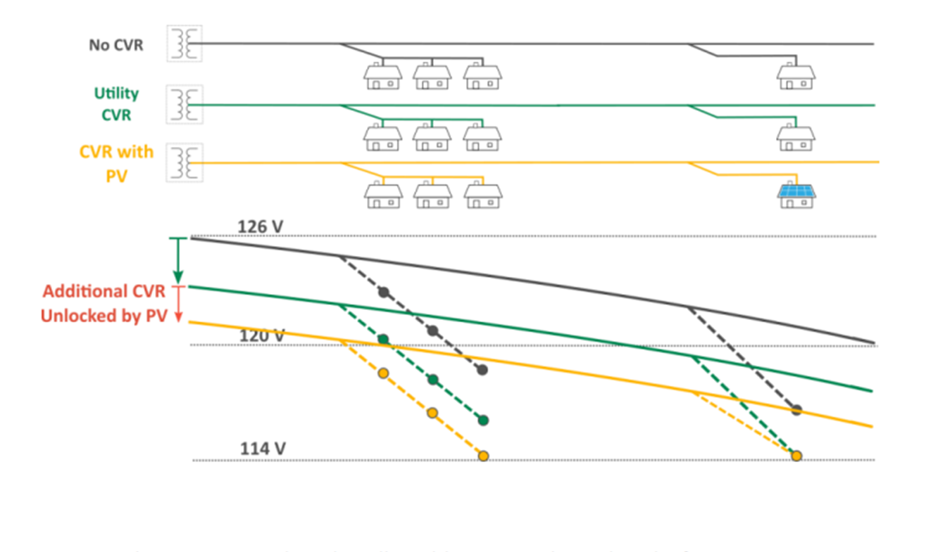
Specifically, this diagram (Figure 1) does not take account for customers downstream of the house with the ability to raise voltage at their location. In reality (Figure 2), if customers exist downstream of the same feeder, on unsupported bifurcated mainline, or on other feeders served out of the same substation without smart inverter functionality, these are at risk of being served high or low voltage.
Figure 2 – Customer without Smart Inverter Function Located at EOL Served Low Voltage
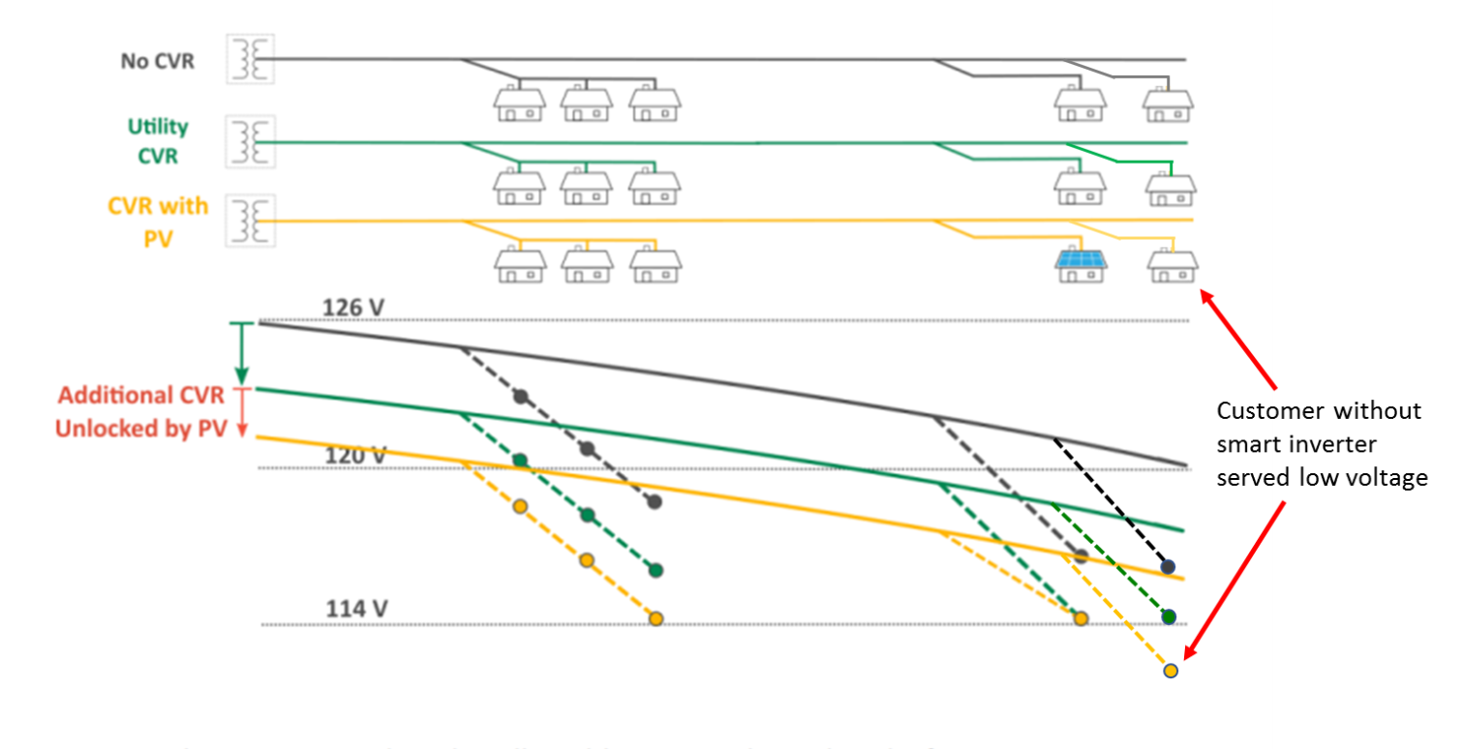

To implement CVR without the risk of serving low voltage to customers, all feeders connected to a substation need to be integrated in the CVR scheme and analyzed for voltage and loading impacts. Similarly, smart inverters would need to be strategically placed and programmed on all the feeders based on equipment and feeder characteristics to potentially achieve CVR benefits without detrimentally impacting customer voltage.

Communication and Data Systems are Necessary to Enable CVR
System-wide CVR benefits are unachievable in scenarios where smart inverters operate independently, without understanding the real time operations of the other smart inverters connected to the same substation bus. Centralized communication and control is essential to optimize the VAR production on the system to maintain required voltage levels. To calculate real time optimized smart inverter behavior, substation and feeder voltage data paired with smart inverter VAR production data must be transmitted to a centralized location. Distribution management systems would need the ability to send signals directly to smart inverters to inject or absorb VARs via Distributed Energy Resource Management System (DERMS) or Grid Management System (GMS). Due to the constant voltage changes throughout each day caused by the change in load, real time data acquisition and control is imperative. Moreover, the substation bus voltage and VAR sources must be dynamic. Additional communication and sensing equipment is required to achieve these functional capabilities. Without these capabilities smart inverters are blind to grid conditions that surround them unable to communicate with utility equipment and other neighboring smart inverters. These barriers would make it impossible to maintain the optimal voltage along a feeder to achieve CVR for customers.

Existing CVR Activities/Pilots Can Provide Insights
SCE is currently deploying a more “active” approach to CVR, called Distribution Volt/VAR Control (DVVC). The current deployment of DVVC is based off of a central control algorithm that was developed to control VAR producing equipment for applicable system configurations. Strategically placed capacitors on distribution feeders, combined with the centralized control algorithm and voltage sensing on distribution feeders and substations, enable DVVC to capture potential CVR benefits. To achieve CVR benefits, SCE has found that additional equipment must be deployed to enable the monitoring and control of all VAR sources connected to a single substation bus. This equipment is needed to optimize voltage levels throughout the distribution system. In addition, as part of SCE’s Integrated Grid Project (IGP), SCE is examining software that can potentially calculate optimal VAR dispatch to minimize circuit voltage.
To quantify the benefits of different control algorithm schemes and system configurations, technical studies are needed to quantify the benefits of different CVR implementations versus non volt VAR optimizations. The IOUs are currently performing pilot studies to test the capabilities required to achieve CVR benefits.

LNBA Incorporation
The LNBA should incorporate real achievable avoided costs that DERs can provide. Considering the sensing and communication equipment required to implement CVR with smart inverters, the IOUs should continue the ongoing research to understand how to achieve this before incorporating CVR energy savings as a benefit within the LNBA. Realizing CVR through smart inverters with existing capabilities is not technically feasible for deployment or regular existing operations. In addition to studying the feasibility of utilizing smart inverters to maintain voltage at optimized levels, the actual calculated benefits of CVR should be further explored. It is currently very difficult to calculate actual recorded energy savings from the reduction in voltage. Before incorporating a benefit value related to CVR within the LNBA, the actual benefit of CVR needs more research and refinement.
It is important to note that CVR at its core is an energy efficiency measure. While we can all agree the pursuit off energy efficiency in the electric system is always warranted it is important to realize that the value streams generated by energy efficiency programs are mostly realized by individual customers and not ratepayers as a whole. As specific customers operate more efficiently through optimized voltage levels in CVR they will realize the financial benefit of having to pay for less kWh consumed. There is no energy cost change relative to the rest of ratepayers because even though the utility will have to procure less energy, the customers benefitting from CVR will pay an equivalent amount less in energy costs. Furthermore, as the customers pay for less kWh their overall contribution to T&D costs will decrease while no decrease in utility T&D investment may be realized, thereby increasing T&D cost relative to other ratepayers resulting in additional cost shift. As smart inverters are capable of implementing CVR locally for customers and these benefits are only realized by those customers, one could argue that the value of efficiency gains through CVR is already accounted for and can be marketed to customers directly.

The SEIA/Tesla proposal references this NREL study of one PG&E feeder: https://www.nrel.gov/docs/fy17osti/67296.pdf. The study finds that for this feeder, voltage optimization accounts for approx. 90% of the observed CVR benefit and smart inverters account for approximately 10%.

